**Usefulness of Results Research**

**Schacter & Singer and Cognitive Behavioural Therapy**

1. What is the two-factor theory of emotion?
   1. People’s emotion not only depends on their biological reaction, but also the environment around them.
2. What are some physiological changes associated with someone who has a phobia and is exposed to the phobic stimuli?
   1. Heart rate increase, sweet
3. What is the emotion felt when the person is exposed to the phobic stimuli?
   1. Nervous, excited, tension, anxiety
4. Based on the two-factor theory how could this emotion be prevented from being felt?
   1. Use drugs to manually decrease heart rate
   2. Change the environment to make the emotion calm
5. Read the passage below.

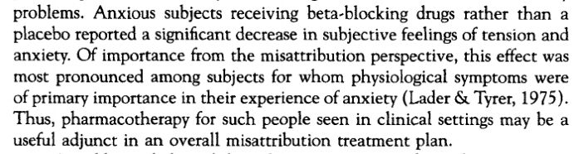

* 1. What drugs could be used to treat the phobia? and briefly describe how they work (research this last bit).
     1. Beta-blocking drugs
     2. The drug decreases people’s physiological symptoms
  2. Research (this is part of CBT) how else physiological arousal might be controlled.
     1. Ask therapist for help
     2. Change the environment that makes people feel nervous
  3. Explain this would stop the feeling of anxiety according to the two-factor theory.
     1. The therapist could give help such as drugs to keep the physiological part of the emotion calm
     2. With the change of environment, people will judge their physiological feeling with another explanation. Therefore, their emotion will be changed

1. Read the Passage below.

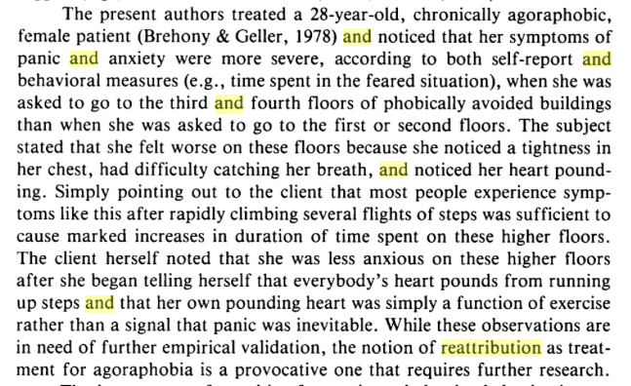

* 1. What is acrophobia?
     1. Acrophobia is an anxiety disorder caused by height, when someone with acrophobia is standing on a high place, they will feel nervous and tension. Physiological reactions including heart pumping faster and stronger, people with this disorder will also feel hard to breath when they are on a high place.
  2. Briefly research: what is meant by attribution and reattribution therapy?
     1. Attribution therapy: a form of therapy in which the therapist tries to modify a client's attributions of events and behaviour.
     2. Reattribution therapy: a form of therapy that tests automatic thoughts and assumptions by considering alternative causes of events.
  3. What physiological changes were experiences by the acrophobic as they walked up the stairs? What did they attribute this change to?
     1. Their heart beat frequency and magnitude increased, their lung also feel hard to breath.
  4. How was the physiological change reattributed by the therapist?
     1. The patient was convinced that their physiological reactions are normal so that they won’t attribute their reactions to the fear of height

**Dement & Kelietman and Alarm Clock Smartphone Apps**

I suggest you download and use the APP o gain a better understanding of how the APP works (and to wake up in a better mood eachday). The app can be downloaded from itunes and possibly other app stores. Even if you are unable to download the app you can still research how the app works at sleepcycle.com.

1. Describe how the app works.
2. How did the work of Dement and Keltiman contribute to the creation of this app? In you answer, discuss different stages of sleep and EEG data.